|  |  |  |  |
| --- | --- | --- | --- |
| **COURSE NAME / CODE** | | | BTEC National Subsidiary / Diploma / Extended Diploma in IT |
| **UNIT(s) No / Name** | | | Unit 6 – Software development |
| **LEVEL** | 3 | Assignment No & Title | Assignment 2/Good design |

|  |  |  |  |  |  |
| --- | --- | --- | --- | --- | --- |
| **LECTURER/ASSESSOR** | Emmanuel Oladipo/ | | | | |
| **ISSUE DATE** | 02/11/2015 | **DEADLINE DATE** | | 02/12/2015 | |
| **SUBMISSION DATE** |  | |  | | |
| **RESUBMISSION AUTHORISATION**  BY LEAD INTERNAL VERIFIER* |  | | **Authorisation Date (By iv)** | |  |
| **RESUBMISSION DATE\*\*** |  | |  | | |

|  |
| --- |
| **\***All resubmissions must be authorised by the **Lead Internal Verifier**. Only **one** resubmission is possible per assignment, providing:   * The learner has met the initial deadlines set in the assignment, or ha met an agreed deadline extension * The tutor considers that the learner will be able to provide improved evidence without further guidance * Evidence submitted for assessment has been authenticated and accompanied by a signed and dated declaration of authenticity by the learner   **Any resubmission evidence **must** be submitted within 10 working days of receipt of assessment |

**Student declaration**

*I declare that this assignment is all my own work and the sources of information and material I have used (including the internet) have been fully identified and properly acknowledged as required.*

|  |  |
| --- | --- |
| **STUDENT NAME** | **SIGNATURE** |
|  |  |

**ASSESSMENT DETAILS & GRADING CRITERIA**

(NB: Columns 1 &2 of the table below will be completed once the assignment has been submitted) Please note that criteria & evidence should be aimed to give the learner the maximum grade available within their qualification (i.e. A, Pass, Distinction)

|  |  |  |
| --- | --- | --- |
| **Learning Aims Covered** | | |
| LO3 | | Be able to use tools to demonstrate software designs | | | | | | | | |
| **GRADING CRITERIA FOR TASK** | | | **EVIDENCE** | **EVIDENCE SEEN** | | **Page No#** | **CRITERIA MET** | | | |
| **Y** | **N** | **Y** | **I** | **N** | **IV** |
| P6 | Use appropriate Tools to design a solution to a defined statement | | **Task 1: Storyboard** detailing the **designs** for your **user Interface**.  **Data dictionary** |  |  |  |  |  |  |  |
| M2 | Justify the choice of data types and software structures used in a design solution. | | **Task 1: A report or a table** on **data types** and the justification of each type |  |  |  |  |  |  |  |
| D2 | develop algorithms to represent a design solution | | **Task 1: Algorithm** or **pseudo code** and **program flow diagram** |  |  |  |  |  |  |  |

**KEY: Y = Yes, I = Incomplete, N = No**

**BREAKDOWN OF HOW GRADES WILL BE AWARDED:**

(NB: Please tick as appropriate)

|  |  |  |
| --- | --- | --- |
| **TYPE OF QUALIFICATION** | **TICK** | **DESCRIPTION** |
| **BTECS / WORKSKILLS** | **√** | Pass / Merit / Distinction / Fail |
| **A LEVELS / A2** |  | A-U |

**Internal Verification of Assignment Brief**

|  |  |  |  |  |  |
| --- | --- | --- | --- | --- | --- |
| **IV Full Name** |  | **Signed** |  | **Date:** |  |
| **LIV Full Name** |  | **Signed** |  | **Date:** |  |

 **BTEC Sample Material**

**Learner Consent Declaration**

|  |  |  |
| --- | --- | --- |
| **Centre No & Name** | **51330 – UTC Reading** | |
| **Subject & Level** | **BTEC National Subsidiary / Diploma / Extended Diploma in IT** | **3** |
| **Unit No & Title** | **Unit 06 –** Software development | |
| **Learner No & Name** |  | |

I agree to the learner work identified above, after having been made anonymous, being used to support any of the following activities, which may involve the display of work online through the BTEC website or through publications:

* Professional Development and Training
* Centre Assessment Example Material
* Standardisation Support
* Publication Materials

|  |  |
| --- | --- |
| **Assessor Signature** |  |
| **Name** (block capitals please) |  |
| **Job Title** |  |
| **Date**: |  |

|  |  |
| --- | --- |
| **Learner Signature** |  |
| **Name** (block capitals please) |  |
| **Parent/Guardian consent if under 16 years of age** |  |
| **Date**: |  |

Please ensure that this sheet is completed on submission of your assignment.

Unit: 06

*Software Design and Development*



Assignment: 2

*Good design*

Please note that your assignment **MUST** have the following:

1. Cover page
2. Contents page
3. Introduction
4. Conclusion
5. Bibliography

2

You work as a trainee developer and your firm have decided you are now ready to tackle your first programming solution. To show your skills that you have learnt during the time you have been with the firm, you have been asked to choose from one of the scenarios below and to produce the following for your given scenario.

**TASK 1**

Design of your solution

* 1. Hierarchy charts, form sketches and description and annotated algorithms (simplified code) to plan out your program.

Pseudo code of your proposed solution

Data dictionary of data types used in your solution (including justification of why you picked them)

* 1. all input and output data and justify why each piece of data is important to your program Implement your solution.

Work is to be submitted as a single report containing evidence of all the design work you have undertaken above

**P6** - Create a storyboard showing your designs for your

User Interface.

Create a data dictionary – listing all your variables, data types and why you have chosen them

**M2** - When you list your data types you have chosen–justify why they are the best to use. Consider ranges ofacceptable input.

**D2** –when implementing your solution. Create algorithms using pseudo code to plan out your solution.Build your solution

Annotate your code and pseudo code with comments explaining how it works and how it makes it more efficient



**SCENARIO 1** You have been hired by an interior decorating firm to estimate costs of painting a room. They wantto be able to input a value between 2 and 6 metres for room height, then the lengths of the four walls (between 1m and 25m).

They want to be able to choose:

Wallpaper - £8 per square metre

Luxury paint - £1.75 per square metre Standard Paint - £1 per square metre

Economy paint - £0.45 per square metre

Optional additional undercoat - £0.50 per square metre

They would like the program to estimate the labour costs on top - £12 per hour, it takes about 0.25 hour to paint 1 square metre.

The output of your program should be a nicely laid out estimate of the costs based on a customer’s room size (e.g. 5m x 5m x 2m) that can be printed showing the different overall totals for the different paints.

The customer can use their estimate to make the best choice for their room.

The customer would be interested in any other advanced features that your program may be able to offer, be creative and think of any other tools that may be of interest to an interior designer.

The application can either be built for the PC or for a mobile device.

3

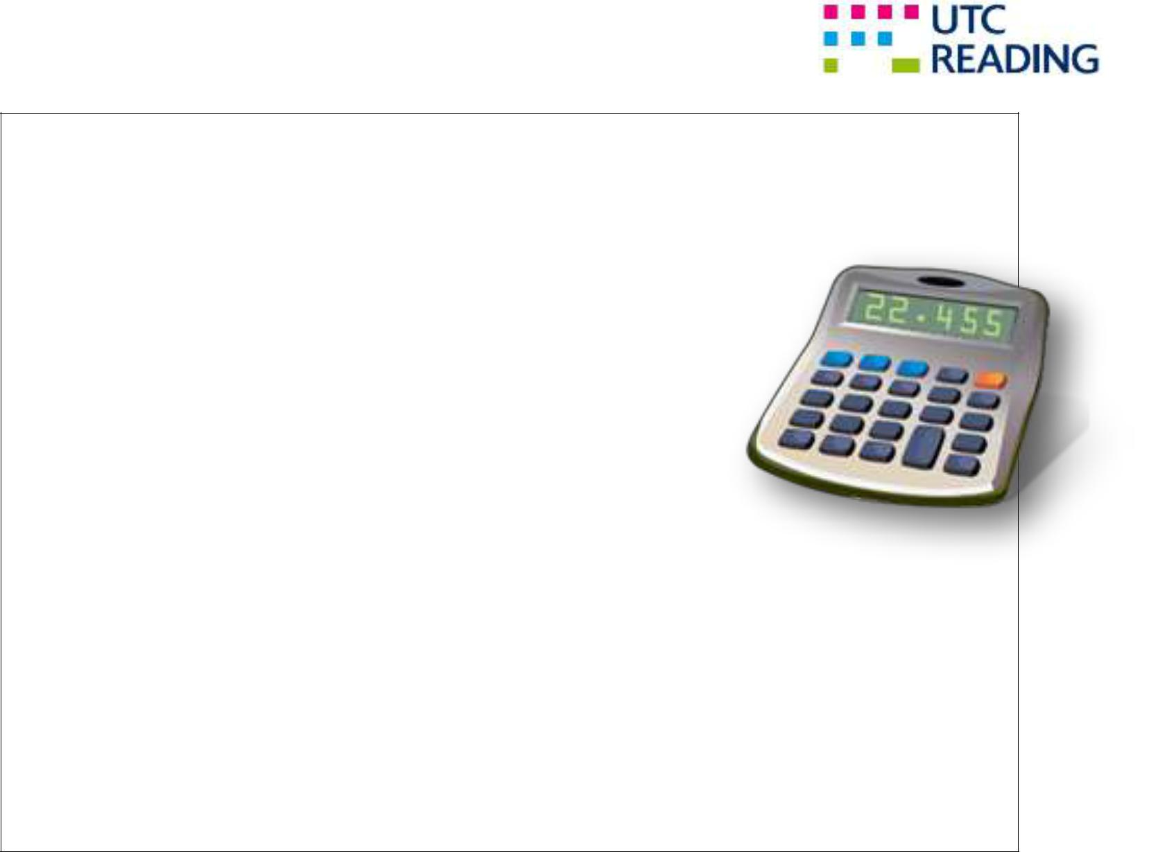

**SCENARIO 2** You have been asked to redesign the conventional calculator program. You have been asked toensure it provides all the standard functions and should have the option for extended functionality.

They want to be able to choose:

Addition

Subtraction Division

Multiplication

Optional functions

1. Number bases
   * Binary
   * Hexadecimal
   * Octal
2. Trigonometry
   * Sin
   * Cos
   * Tan

The application can either be built for the PC or for a mobile device.

The output of your program should be a nicely laid out and should provide ease of use to the user. It should also have a help facility.

There should be the option of adding additional modules to the application that would extend the functionality of the program. Modules would be further mathematical functions that you can choose. This does not have to be coded but should be mentioned to show extendibility of application.

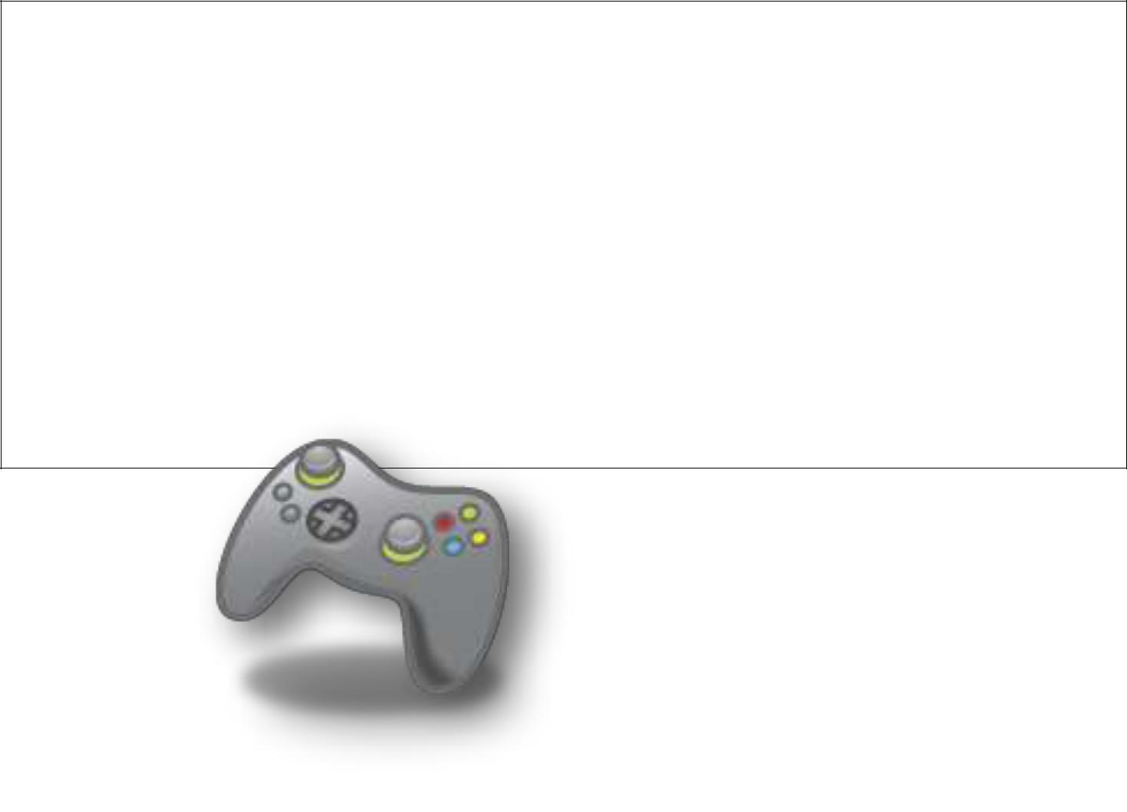

**SCENARIO 3** You have been asked to create a game. The game can be anything of your choosingwithin reason but should display your programming expertise in creating a user friendly user interface. Your game should produce user scores and allows the user to add elements into the original ‘game’ to boost their potential in gaining a higher score.

The application can either be built for the PC or for a mobile device.

The output of your program should be a nicely laid out and should provide ease of use to the user. It should also have a help facility to show the user how to play your game.

There should be the option of adding additional modules to the application that would extend the functionality of the program. Modules would be for a further development that is NOT covered in this application. This does not have to be coded but should be mentioned to show extendibility of application.

4



**FOR THE PASS CRITERIA**

**P6** Storyboard of designs for solution

User interface

Data dictionary

**FOR THE MERIT CRITERIA**

Why data types were chosen

**M2** Why it was the best data type to use over others

Range of acceptable input

**FOR THE DISTINCTION CRITERIA**

Algorithms used in pseudo code and code Completed solution

**D2** Annotation of code / pseudo code detailing how code works and how / when it’s more efficient

5

Marking Sheet for Unit 06 Software Design and Development Assignment 2

P6

M2 D2



 Design of chosen scenario

 Storyboard of solution

 Pseudo code of solution

 Data dictionary

Data types and why you chose them (extension from P6)



 Ranges of acceptable input

Algorithms in pseudo code used in the solution



Annotation in code (how it works / it is more efficient)



Annotation in pseudo code (how it works / it is more efficient)



**Textbooks**

1. Bowman K – *Systems Analysis: A Beginner’s Guide* (Palgrave Macmillan, 2003) ISBN-10 033398630X, ISBN-13 978-0333986301

2. Flanagan D – *JavaScript Pocket Reference, 2nd Edition* (O’Reilly, 2002) ISBN-10 0596004117,

ISBN-13 978-0596004118

1. Knuth D – *The Art of Computer Programming: Volumes 1–3, 2nd Edition* (Addison Wesley, 1998)

ISBN-10 0201485419, ISBN-13 978-0201485417

1. Wang W – *Visual Basic 6 for Dummies* (John Wiley & Sons, 1998) ISBN-10 0764503707,

ISBN-13 978-0764503702

1. Wender K – *Cognition and Computer Programming* (Ablex Publishing Corporation, 1995)

ISBN-10 1567500951, ISBN-13 978-1567500950

1. Willis T, Crossland J and Blair R – *Beginning VB.NET, 3rd Edition* (John Wiley & Sons, 2004)

ISBN-10 0764556584, ISBN-13 978-0764556586

**Websites**

www.guidetoprogramming.com/joomla153

www.profsr.com

www.vbexplorer.com/VBExplorer/VBExplorer.asp

visualbasic.about.com

|  |  |  |  |
| --- | --- | --- | --- |
| **Summative comments** | | | |
|  | | | |
| **Assessors declaration** | | | |
| I certify that the evidence submitted for this assignment is the student's own and the learner will be able to provide improved evidence without guidance. I understand that any false declaration is a form of malpractice. | | | |
| **Resubmission authorisation\*** |  | **Resubmission Date:** | Click here to enter a date. |
| * All resubmissions must be authorised. Only 1 resubmission is possible per assignment. | | | |
| **Assessor Signature** |  | **Date:** | 28 September 2015 |
| **Learner comments** |  | | |
| **Learner Signature** |  | **Date:** |  |

|  |  |  |  |  |  |  |
| --- | --- | --- | --- | --- | --- | --- |
| **SUMMATIVE ASSESSMENT RECORD SHEET** | | | | | | |
| **Programme** |  | | **Learner Name** |  | **Assessor Name** |  |
| **Unit No. & Title** |  | | **Target Learning Aims** |  | **Issue Date** | Click here to enter a date. |
| **Assignment No & Title** |  | | | | **Final Submission Date** | Click here to enter a date. |
| **Target criteria** | **Criteria Achieved** | **Final Assessment Comments** | | | | |
|  |  |  | | | | |
|  |  |  | | | | |
|  |  |  | | | | |
|  |  |  | | | | |